 | Document Number | EDCS-15612474
 | Based on Template | EDCS-189229 Rev 23
 | Created By | Niels Jensen  Jeffery Loo

Fugazi
Hardware Functional Specification

This is the hardware functional specification for the Fugazi platform. Fugazi is a Low- End ASR1K platform using a software dataplane.

Reviewers
Department | Name / Title
SRGBU HW | Kevin Ye / Hardware Manager

Modification History
Revision | Date | Originator | Comments
1 | 12/6/2018 | Niels Jensen | Initial checkin
2 | 3/5/2019 | Niels Jensen | Updates for revision 1
3 | 12/18/2019 | Niels Jensen | Cleanup and remove incorrect and out-of-date stuff.
4 | 4/23/2020 | Niels Jensen | Adding USB description. Minor clarifications added.
5

Table of Contents
1 Overview 7
1.1 Risks 7
1.2 Design Considerations 8
1.2.1 NEBS requirement 8
1.2.2 Hardware Process Requirements 8
2 High-Level Description 9
2.1 Configurations 9
2.1.1 Fugazi Bezel Side 9
2.1.2 Fugazi Business (I/O Panel) Side 9
2.2 Performance 10
2.3 Functional Blocks 10
2.4 Theory of Operation 10
2.5 Initiative, Legal, & Regulatory 10
3 Detailed Description 11
3.1 System Block Diagram 11
3.2 Intel Skylake-D Control Plane CPU 11
3.2.1 Control Plane CPU Part Numbers 11
3.2.2 Skylake-D CPU 12
3.2.3 Skylake-D DDR4 12
3.2.4 Skylake-D Flexible HSIO 13
3.2.5 CPU USB Mapping 14
3.2.6 CPU PCIe Mapping 14
3.2.7 CPU PCIe Output Clock Mapping 14
3.2.8 CPU Ethernet Mapping 15
3.2.9 CPU RTC 15
3.3 DDR4 Memory DIMMs 15
3.4 Bootflash 16
3.5 UARTs (Serial Ports) 16
3.5.1 CON RS-232 Transceiver 16
3.5.2 RJ-45 Connector Pin Out 16
3.5.3 USB Console 17
3.6 Front USB Ports 17
3.6.1 USB 3.0 Type-A 18
3.6.2 USB 3.0 Type-C 18
3.6.3 USB High Speed Re-driver 19
3.7 Front Panel Ethernet Ports 19
3.7.1 i211 GE MAC/PHY Management Port 19
3.7.2 Dual 10G MAC, BCM57412 19
3.7.3 Quad GE PHY BCM54194 20
3.7.4 Dual 10G PHY BCM82757 21
3.7.5 1G and 10G PHY SMI Address Map 22
3.7.6 SFP/SFP+ Interface 23
3.8 I2C 24
3.9 Clocks 24
3.9.1 SyncE 24
3.9.2 Miscellaneous clocks 26
3.10 IO FPGA 26
3.11 LED Daughter Card 26
3.12 Trust 2.0 26
3.13 Fan tray connector 27
3.14 Current Measurement 27
3.15 JTAG Chain 29
3.16 Power 30
3.16.1 Voltage Margin 30
3.17 M.2 Expansion Flash 30
4 Software Considerations 32
4.1 Memory Maps 32
4.2 Programming Requirements / Suggestions 32
4.2.1 BIOS 32
4.2.2 BCM57412 32
4.2.3 BCM82752/BCM82757 32
4.2.4 FPGA Programming Requirements 33
4.3 Other Software Considerations 33
4.3.1 Cookie EPROM 33
5 User Interface Considerations/ User Experience 34
5.1 LEDs 34
6 Power Supply Requirements 35
6.1 Power Budget 35
6.1.1 Power Budget Summary 35
6.2 Main Power Supplies 35
7 Mechanical Description 36
8 Signal Integrity Considerations 37
8.1 Impedance Control 37
8.2 Signal Crosstalk 38
8.3 PCB Routing Requirements 38
8.4 PCB Stackup 38
8.5 Simulation Results 39
9 Testing Considerations 40
10 Testability Considerations 41
11 Manufacturing Considerations 42
11.1 System, Board Part Numbers 42
11.2 Programmable Part Numbers 42
11.3 Power Supply Part Numbers 43
12 Estimated Costs 44
13 Requirements Traceability Considerations 45
14 References 46
15 Standards 47
15.1 Safety Standards 47
15.2 EMC Standards 47
16 Glossary 49
17 Attachments 50
17.1 Review Action Items 50
17.1.1 Review Notes 50

Table of Figures
Figure 1. Fugazi Bezel Side View. (Not to scale.) 9
Figure 2. Fugazi Business Side View. (Not to scale.) 9
Figure 3. Fugazi High Level Block Diagram 11
Figure 4. Skylake-D Block Diagram 12
Figure 5. Skylake-D Flexlible HSIO 13
Figure 6. Fugazi UARTs 16
Figure 7. BCM87412 block diagram – from datasheet 20
Figure 8. BCM54194 Quad 1G PHY block diagram – from datasheet 21
Figure 9. BCM82757 Dual 10G PHY block diagram – from datasheet 22
Figure 10. SMI addresses for 1G Quad PHYs 22
Figure 11. SMI addresses for 10G Dual PHYs 23
Figure 12. Fugazi I2C Busses 24
Figure 13. Fugazi SyncE Clock Tree 25
Figure 14. Trust 2.0 implementation using Aikido. 27
Figure 15. Trust 2.0 implementation using Aikido – proto type only. 27
Figure 16. Fugazi 1RU System Current Sensors 27
Figure 17. Fugazi JTAG Chain 30
Figure 18. M.2 NVME/SATA/USB Block Diagram 31
Figure 19. Fugazi Motherboard 14-layer Stackup 39

Table of Tables
Table 1. Fugazi High level Hardware Feature List 7
Table 2. Fugazi Risks. 7
Table 3. Control Plane CPU Manufacturers Part Numbers. 11
Table 4. Skylake-D CPU USB Bus Mapping 14
Table 5. Skylake-D CPU SOC PCIe Port Mapping 14
Table 6. Skylake-D CPU Clock Output Mapping 14
Table 7. Supported DDR4 DIMMs. 15
Table 8. RJ-45 CON/AUX Pin Out. 17
Table 9. Micro-USB Console / AUX dongle Pin Out. 17
Table 10. USB 3.0 Type-A Pin Out. 18
Table 11. USB 3.0 Type-C Pin Out. 18
Table 12. SFP/SFP+ pin-out 23
Table 13. IDT8A35004 input clock Specifications. 25
Table 14. IDT8A35004 output clock Specifications. 25
Table 15. Miscellaneous Clocks for Fugazi 26
Table 16. Fugazi Fan Connector Pinout 27
Table 17. Fugazi Motherboard Input Current Sensing 28
Table 18. Fugazi Fan Current Sensing 29
Table 19. Supported M.2 NVME Modules 31
Table 20. M.2 Expansion Slot Pin to Module Description. 31
Table 21. Fugazi LEDs. 34
Table 22. Curie Radium High Level Power Budget 35
Table 23. Signal Crosstalk Requirements 38
Table 24. System Part Numbers. 42
Table 25. Fugazi Programmable Part Numbers. 42
Table 26. Fugazi Power Supply Part Numbers. 43
Table 27. Fugazi required EMC Standards. 47
Table 28. Review Action. 50

Overview
The Fugazi program is a low-end ASR platform that leverages the software-based forwarding technology targeting 20Gbps performance on low-cost System on a Chip (SoC) CPUs and fills a space between the high-end ISR products and the ASR hardware-based forwarding platforms.

High-level designs features are shown in Table 1. The table is copied from the Fugazi System Functional Specification, EDCS-15396836. Refer to the SFS for any discrepancies.

Table 1. Fugazi High level Hardware Feature List
Feature
Form Factor | 1RU
Data Plane CPU/Memory | Single SoC with shared CPU and memory between control and data plane
System CPU | Intel Skylake-D 2.5G+ 12C
System Memory Default | 2xDIMM slots, 1x16GB DDR4 default
System Memory Upgrade Options | 32GB and 64GB
Boot Flash | 16GB soldered down.
SSD | M.2 (600GB NVME, 2TB NVME, 16GB USB, or 32GB USB)
Front Panel Ports | 4x10G SFP+  8x1GE SFP
Management GE Port | 1 x RJ45 10/100/1000Mbps
Console Port | 1xRJ45 and  1xUSB micro type-B
Aux Port | Support via micro-USB (Star dongle) without modem control signals
USB Port | 1xUSB 3.0 Type-A (1100mA)  1xUSB 3.0 Type-C (1.5mA)
Fans | Internal
NEBS | Yes
Removable Main PSU  (Redundant Mode) | 2x 500W AC  2x 437W DC  2x 400W HVDC/AC

Risks
Most components that are used in Fugazi are used in the Curie 1RU, 2RU and Green Day projects. The risk for Fugazi is therefore low.

Table 2. Fugazi Risks.
Risk | Mitigation
Aikido implementation of Trust 2.0 | Similar to Curie and Green Day/Ramones. No mitigation.
SyncE | Similar implementation to Green Day/Ramones. No mitigation
Performance | SW based forwarding plane – new to ASR platforms.

Design Considerations

NEBS requirement
NEBS will be required. No special airflow will be necessary.

Hardware Process Requirements
Fugazi will follow the guidelines set out in CHG Hardware Development Process, EDCS-1511434 [8].

Also, Fugazi will follow normal Cisco Derating Guidelines as specified in [9].

High-Level Description

Configurations

Fugazi Bezel Side
The side where the fans are located is referred to as the bezel side – even though there is no separate bezel present on this box. The bezel side has the 4fans (numbered left to right) and access to 2 PSU power supply bays can be found. The On/Off switch is used to turn on and gracefully turn off the system; no separate on/off switch exists on the power supplies. One power supply can be removed while the system is powered by another power supply; however, the AC cable must be removed before power supply removal latch can be disengaged.

The bezel side has the following interfaces:
- 2 PSU Slots
- System Power On/Off switch
- Fan exhaust

Figure 1. Fugazi Bezel Side View. (Not to scale.)

Fugazi Business (I/O Panel) Side
The business side has access to Ethernet ports. The following interfaces are available:
- 1 USB 3 Type A host ports
- 1 USB 3 Type C host ports
- 1 USB micro-Type B Console port
- 1 RJ45 Console port
- 1 10/100/1000 RJ-45 Management Ethernet port
- 8 1G SFP Ethernet ports (labeled “GE0/0/0-GE0/0/7”)
- 4 1G/10G SFP/SFP+ Ethernet ports (labeled “TE0/1/0-TE0/1/3”)
- M.2 Flexible NVME / USB slot
- LEDs for Ethernet and console status
- Status/Alarm LEDS and backlit Cisco Logo

Figure 2. Fugazi Business Side View. (Not to scale.)

Performance
Refer to the Fugazi System Functional Specification, EDCS-15396836.

Functional Blocks
See section 3.

Theory of Operation
Refer to the Fugazi System Functional Specification, EDCS-15396836.

Initiative, Legal, & Regulatory
N/A

Detailed Description

System Block Diagram
A high-level block diagram is shown in Figure 3.

Figure 3. Fugazi High Level Block Diagram

Intel Skylake-D Control Plane CPU

Control Plane CPU Part Numbers
Table 3 shows the Control Plane CPUs.

Table 3. Control Plane CPU Manufacturers Part Numbers.
Port | Fugazi
Vendor | Intel
SKU | D-2168NT
MPN | FH8067304217500 QRJF
CPN | 15-106911-01
Cores | 12
Cache | 16.5MB
Speed | 2600MHz
Power | 110W

Skylake-D CPU
Fugazi uses a 12-core Skylake-D processor from Intel’s Xeon D-2100 product family. Figure 4 shows a high-level block diagram of Skylake-D. The main features of the processor include:
- 2.6GHz Xeon Processr
- 12 cores
- 1MB/Core Cache
- Up to 4 DDR4 channels (up to 2DIMMs / channel, up to 2133 MT/s data rate)
- Up to 4 ports 10 GbE/1GbE Integrated Ethernet (Supports KR/KX/SFI) supporting SR-IOV
- x32 PCIe Gen3 + up to 20 PCIe Gen3 lanes via Flexible IO
- 20 High-Speed Flexible Lanes configured as PCIe or SATA or USB3.0 (Up to 20 lanes of PCIe 3.0 or Up to 14 lanes of SATA Gen 3 or Up to four ports of USB Gen 3)
- FCBGA 45 mm x 52.5 mm, Socket-less FCBGA-2518

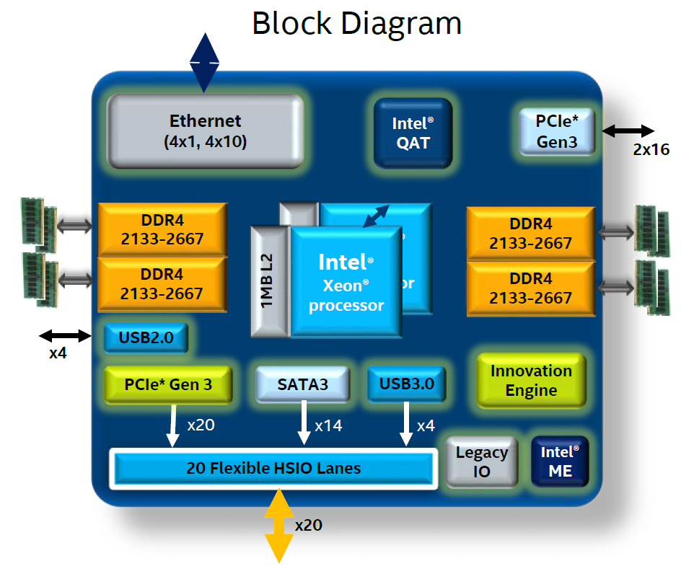
Figure 4. Skylake-D Block Diagram

Skylake-D DDR4
Skylake-D has 4 DDR4 controllers. The Intel documentation refers to these as 0, 1, 3, 4 and A, B, D, E; in this HFS and schematic documentation the integer notation will be used. Fugazi will use controller 1 and 4, and they are located physically on either side of the CPU. The selection is based on ease of routing. Each channel will have one DIMM slot.

DDR4 channel 0/1 and 3/4 have separate voltage domains, hence two separate voltage rails are required.

Note that there are several rules that apply to the memory. From the PDG the following is listed for mixing DIMMs:
- All DIMMs must be DDR4 DIMMs.
- x4 and x8 DIMMs can be mixed in the same channel.
- Mixing of LRDIMMs and RDIMMs is not allowed in the same channel, across different channels, and across different sockets.
- Mixing of non-3DS and 3DS LRDIMMs is not allowed in the same channel, across different channels, and across different sockets.
- Mixing of DDR4 operating frequencies is not validated within a socket or across sockets by Intel. If DIMMs with different frequencies are mixed

The I2C addressing for the DIMMs will be 0xA4 for both. This is specified in the PDG table 6-3.

Skylake-D Flexible HSIO
Skylake-D has 26 flexibile High Speed I/O ports that supports various controllers; 20 HSIOs are available for the user. An overview from the CPU datasheet is shown in Figure 5.
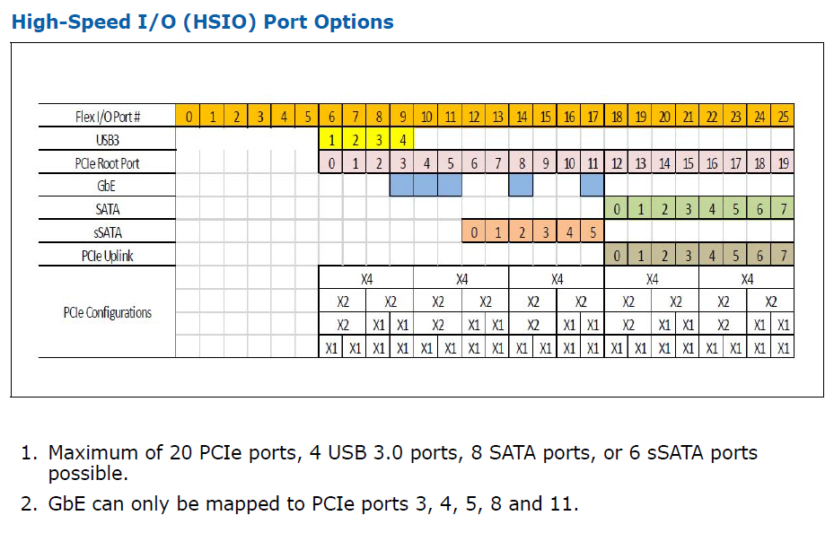
Figure 5. Skylake-D Flexlible HSIO

Fugazi uses 2 USB3 lanes but should be configured for 4 lanes, and 16 PCIe lanes. See 3.2.5 for USB mapping and 3.2.6 for PCIE mapping

CPU USB Mapping
Table 4 shows the USB port mapping.

Table 4. Skylake-D CPU USB Bus Mapping
CPU USB port | Neptune
USB 2.0, Port 0 | Front-Panel USB Type A, Port 0
USB 2.0, Port 1 | Front-Panel USB Type C, Port 1
USB 2.0, Port 2 | eMMC controller
USB 2.0, Port 3 | M.2 USB slot
USB 3.0, Port 1 | Front-Panel USB Type A, Port 0
USB 3.0, Port 2 | Front-Panel USB Type C, Port 1
USB 3.0, Port 5 | Not used
USB 3.0, Port 6 | Not used

CPU PCIe Mapping
Table 5 shows the PCIe port mapping and bifurcation for the Skylake-D CPU.

Table 5. Skylake-D CPU SOC PCIe Port Mapping
PCIe Block | Lane Num, Lane Width | HSIO lane | Symbol Port | Fugazi
CPU PCIe,Gen 3,  PCIE1, x16  (2x4) | [3:0], x4 |  | PCIE1[3:0] | 10G MAC4 (x4, g3)
 | [7:4], x4 |  | PCIE1[7:4] | 10G MAC5 (x4, g3)
 | [11:8], x4 |  | PCIE1[11:8]
 | [15:12], x4 |  | PCIE1[15:12] | NVME (x4,g3)
CPU PCIe, Gen 3,  PCIE2, x16  (4x4) | [3:0], x4 |  | PCIE2[3:0] | 10G MAC0 (x2, g3)
 | [7:4], x4 |  | PCIE2[7:4] | 10G MAC1 (x2, g3)
 | [11:8], x4 |  | PCIE2[11:8] | 10G MAC2 (x2, g3)
 | [15:12], x4 |  | PCIE2[15:12] | 10G MAC3 (x2, g3)
PCH PCIe, Gen 2,  (4x2,2x4) | [4], x1, gen 2 | [10] | PCIE0[4] | FPGA (x1, g1)
 | [5], x1, gen 2 | [11] | PCIE0[5] | -
 | [6], x1, gen 2 | [12] | PCIE0[6] | i211 (x1, g1)
 | [7], x1, gen 2 | [13] | PCIE0[7] | -
 | [9:8], x2, gen 2 | [15:14] | PCIE0[9:8]
 | [11:10], x2, gen 2 | [17:16] | PCIE0[11:10]
 | [15:12], x2, gen 2 | [21:18] | PCIE0[15:12]
 | [20:16], x2, gen 2 | [25:22] | PCIE0[20:16]

CPU PCIe Output Clock Mapping
Table 6 shows the PCIe clock port mapping for the Skylake-D CPU. Note that there are 15 outputs in addition to a separate XDP output. Outputs 3, 4, and 5 have been selected for the 3 CPU BLK inputs.

Table 6. Skylake-D CPU Clock Output Mapping
PCIE clock outputs | Connected Device | Speed
CLK_PCIE_0 | Unused | 100MHz
CLK_PCIE_1 | Unused | 100MHz
CLK_PCIE_2 | Unused | 100MHz
CLK_PCIE_3 | CPU BCLK0 | 100MHz
CLK_PCIE_4 | CPU BCLK1 | 100MHz
CLK_PCIE_5 | CPU BCLK2 | 100MHz
CLK_PCIE_6 | 10G Dual MAC0 | 100MHz
CLK_PCIE_7 | 10G Dual MAC1 | 100MHz
CLK_PCIE_8 | 10G Dual MAC2 | 100MHz
CLK_PCIE_9 | 10G Dual MAC3 | 100MHz
CLK_PCIE_10 | 10G Dual MAC4 | 100MHz
CLK_PCIE_11 | 10G Dual MAC5 | 100MHz
CLK_PCIE_12 | Unused
CLK_PCIE_13 | FPGA
CLK_PCIE_14 | i211 GE MAC
CLK_PCIE_15 | NVME | 100MHz
CLK_PCIE_ITP_XDP | XDP | 100MHz

CPU Ethernet Mapping
Skylake-D’s native 10G Ethernet ports are not used in Fugazi.

CPU RTC
The Skylake-D PCH built in RTC and CMOS memory is used in this design. These are backed-up with a Lithium coin cell CR2032 style battery.

When the system is powered from an external input source the battery is not in use. The expected battery shelf life is:

I_{VCCRTC,typ} = 6µA
Capacity = 220mAh
Calculated Lifetime = 220mAh / 6µA = 36667h = ~ 4 years and 2 months

DDR4 Memory DIMMs
The Intel CPU will have 2 DDR4 DIMM slot. Fugazi plan to support 8GB, 16GB or 32GB RDIMM DIMM. DDR4 will run 2133MT/s. Table 7 shows the planned DDR4 CPNs. Note that these could change during the course of the project.

Table 7. Supported DDR4 DIMMs.
Size | CPN | Description
8GB | 15-107068-01 | IC-DRAM-MOD,DDR4, 8GB (1Gx72),1R,1333MHz(2666MT/s),1.2V NOM, 0°C to 85°C,RDIMM,288P,31.25mm H,8K Cycles,SRGBU Only
16GB | 15-107070-01 | C-DRAM-MOD,DDR4,16GB(2Gx72),2R,1333MHz(2666MT/s),1.2 V NOM,0°C to 85°C,RDIMM,288P,31.25mm H,8K Cycles, SRGBU Only
32GB | 15-107071-01 | IC-DRAM-MOD,DDR4,32GB(4Gx72),2R,1333MHz(2666MT/s),1.2 V NOM,0°C to 85°C,RDIMM,288P,31.25mm H,8K Cycles, SRGBU Only

Bootflash
The bootflash is a soldered down eMMC device. A 16GB device will be used and configured in pSLC mode; this is similar to existing ISR4K systems – please refer to Utah, Sword, Dagger Hardware Functional Specification: EDCS-1202397.

UARTs (Serial Ports)
Figure 6 shows UART busses on Fugazi. The CPU has no UART blocks, hence the console and debug (“AUX”) UARTs will be implemented in the FPGA. UART0 go to the RJ-45 console port or USB console. UART1 will be used for debugging only by providing what software refers to as the “AUX” port. Note that the ‘Star Dongle’ would be required to get the AUX functionality through the Star Dongle’s RJ-45 connection.

In addition, the “AUX” port can be used as a debug port for the FPGA NIOS uP code.

For details on how to configure the multiplexers, please refer to FPGA HFS.

Figure 6. Fugazi UARTs

The front panel Console comply with the Connectors and Cabling Requirements, ENG-97748 document with the exception of DTR and the use of modem signals.

CON RS-232 Transceiver
The transceiver is the MAX3222 which has 2 transmitter blocks and 2 receiver blocks for the RS-232 port. It requires +3.3V power supplies; +/-5.5V is generated internally from a regulated dual charge pump and only one external 0.1uF ceramic capacitor for proper operation. The MAX3222 has ESD protection up to ±15KV.

For the console, the DTR signal is low (system side) when the RJ-45 connector is selected, and high when the USB console is selected.

RJ-45 Connector Pin Out
Table 8 shows the pin out for the CON RJ-45 connector. Only TXD and RXD will be used for the console connection and RTS and CTS are shorted together.

Table 8. RJ-45 CON/AUX Pin Out.
Pin | Signal | Direction
1 | RTS | Output
2 | DTR | Output
3 | TXD | Output
4 | GND | -
5 | GND | -
6 | RXD | Input
7 | DSR/DCD | Input
8 | CTS | Input

USB Console
The USB Console port will be serviced by a UART to USB device transceiver (15-11263-01). If the USB Console Port is active (cable inserted and remote PC drivers enabled), the UART mux in the FPGA should be configured appropriately; by default the console will switch from RJ-45 to USB when the USB cable is detected. USB Console does not support hardware-flow control. For details on this implementation please refer to the USB Console Usage and Design Specification, EDCS-654458.

AUX connection through USB console port.
AUX functionality in the sense that it is needed for software debug is provided on the micro-USB connector by using the dongle that has been developed for the Star fixed platforms. The dongle has an RS232 driver that allows an RJ-45 UART cable to connect to the dongle and the UART signals will be multiplexed directly to the host FPGA.

Micro-USB Console Port Pin-Out
Table 9 shows the pinout for the micro-USB connector in either USB mode or when using the dongle.

Table 9. Micro-USB Console / AUX dongle Pin Out.
Pin | Signal | USB | Dongle
1 | +5V VCC | 5V Power | 5V Power
2 | D- | Data - | TXD output to Dongle
3 | D+ | Data + | RXD input from Dongle
4 | ID | USB console cable has this floating. | Dongle has ID grounded
5 | GND | GND | GND

Front USB Ports
The system has two front panel USB ports: 1 USB 3 Type-A and 1 USB 3 Type-C. They both support USB 2.0 and USB 3.0 at 5Gbps.

USB 3.0 Type-A
The USB 3.0 Type-A connector supports USB 2.0 and USB 3.0 signaling. The pin-out is shown in Table 10. Signal naming for the differential pairs are relative to the host side. High speed signaling is 5Gbps and re-drivers are used for signal conditioning – please see section 3.6.3.

Table 10. USB 3.0 Type-A Pin Out.
Pin | Signal | Description
1 | VBUS | 5V Power
2 | D- | USB 2.0 Data -
3 | D+ | USB 2.0 Data +
4 | GND | GND
5 | SSRX- | USB 3.0 Receive
6 | SSRX+
7 | GND | GND (high speed signals)
8 | SSTX- | USB 3.0 Transmit
9 | SSTX+

Power for VBUS is controlled by a TPS2561 adjustable current limiter; current limiting is set to 1.4A nominal to allow for a guaranteed minimum 1.1A, or ~5.5W power delivery.

USB 3.0 Type-C
The USB 3.0 Type-C connector supports USB 2.0 and USB 3.0 signaling. The pin-out is shown in Table 11. Signal naming for the differential pairs are relative to the host side. High speed signaling is 5Gbps and re-drivers are used for signal conditioning – please see section 3.6.3.

Table 11. USB 3.0 Type-C Pin Out.
Pin | Signal | Description | Pin | Signal | Description
A1 | GND | Ground | B12 | GND | Ground
A2 | TXp1 | First TX differential pair | B11 | RXp1 | First RX differential pair
A3 | TXn1 |  | B10 | RXn1
A4 | VBUS | Power | B9 | VBUS | Power
A5 | CC1 | Configuration  Channel | B8 | SBU2 | Sideband Use
A6 | Dp1 | USB 2.0 Position 1, D+ | B7 | Dn2 | USB 2.0 Position 2, D-
A7 | Dn1 | USB 2.0 Position 1, D- | B6 | Dp2 | USB 2.0 Position 2, D+
A8 | SBU1 | Sideband Use | B5 | CC2 | Configuration  Channel
A9 | VBUS | Power | B4 | VBUS | Power
A10 | RXn2 | Second RX differential pair | B3 | TXn2 | Second TX differential pair
A11 | RXp2 |  | B2 | TXp2
A12 | GND | Ground | B1 | GND | Ground

The USB Type-C protocol requires a DFP (Downstream Facing Port) controller on the host side. A TPS25810 integrated controller and power switch is used on the platform; the controller will monitor the CC1 and CC2 pins on the connector and utilize this information to enable VBUS power and set the polarity for the SerDes multiplexer.

Power for VBUS is set to the 1.5A mode; the TPS25810 provides nominal 1.7A and minimum 1.58A for a ~7.5W power delivery.

A Type-C connector is not keyed and can be oriented in two different ways. A high-speed SerDes mux, HD3SS3212 equivalent, is used to steer the USB 3.0 TX/RX signals to the first or second differential pair on the connector. The mux select and output enable is controlled by the TPS25810.

USB High Speed Re-driver
Due to the distance from the CPU complex to the front-panel USB ports, high-speed re-drivers are used to boost the 5Gbps USB 3 signals. The re-driver used is a PI3EQX7841 or equivalent device with I2C control. The re-driver settings will be programmed by the NIOS environmental controller and adjusted based on bringup lab measurements.

For Fugazi, the maximum settings have provided the most open eye as observed on a high-speed oscilloscope.

Front Panel Ethernet Ports
The front panel Ethernet port connections are shown in Figure 3.

i211 GE MAC/PHY Management Port
Fugazi has a 10/100/1000 GE RJ-45 port for management. An Intel i211 single port MAC/PHY is used to provide the GE connectivity through a CPU PCIe port. MAC addresses will have to be programmed into the onboard EEPROM on the i211, and diagnostics will provide tools for this.

Dual 10G MAC, BCM57412
The BCM57412 is an integrated MAC/PHY LAN controller with support of single 25 GbE ports or dual 10 GbE ports (in Fugazi dual 10G GbE ports is used). Each port can support one of XFI, SFI, 10GBase-KR / CR / SR / LR / ER interfaces. The BCM57412’s host interface supports up to x8 PCIe Gen3 lanes. Fugazi uses x4 PCIe Gen3 lanes for the 10G MACs used for the 10G ports and x2 PCIe Gen3 lanes for the 10G MACS used for the 1G ports.

Figure 7 shows a block diagram copied from the BCM57412 datasheet.

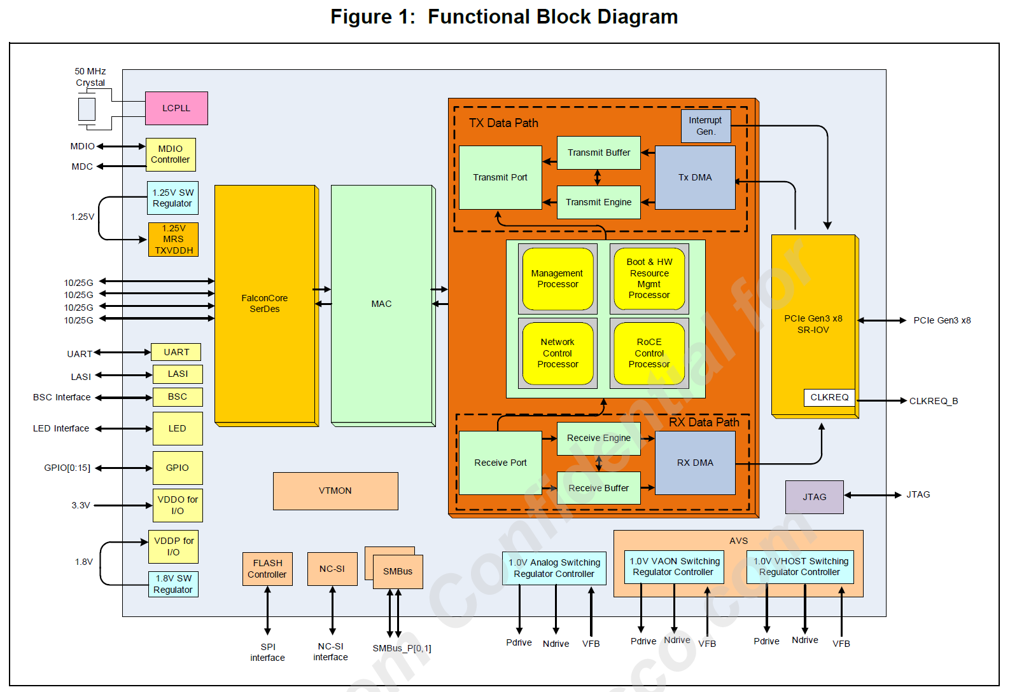
Figure 7. BCM87412 block diagram – from datasheet

The BCM57412 has a SPI interface to connect an external ROM which stores the required boot code, MAC address and configurations.

The management interface can be SMBus, NC-SI or PCIe. In Fugazi, the PCIe interface is used for management.

BCM57412 integrates optical module sideband interfaces to control the external SFP+ optical modules.

BCM57412 has a UART interface for debug purpose which will not be connected on Fugazi.

During the course of Fugazi bringup it has been determined that the default PCIe preset value for BCM57412 is not optimal and can cause PCIe retraining events and in the worst case downgrade from gen 3 to gen1 speed. Testing shows that PCIe Preset 4 is the optimal setting and the configuration files must be updated to reflect this.

Quad GE PHY BCM54194
BCM54194 uses a quad 1G PHY for each 2 SFPs on Fugazi. It is mainly used to provide MacSec support and Cisco Cleartag. The main features applicable to Fugazi are

- SFP Media interface support 1000BASE-X (100M SFPs supported for SGMII upstream applications)
- SGMII or QSGMII interface for System side
- Support for SyncE recovered clocks
- Energy Efficient Ethernet IEEE 802.3az support
- BCM54194 supports 256 bits MACSEC & Cleartag.
- 1.0V core voltage, 3.3V I/O voltage, MDC/MDIO can run at 1.2V/2.5V/3.3V

Figure 8 shows a simple block diagram of the BCM54194.

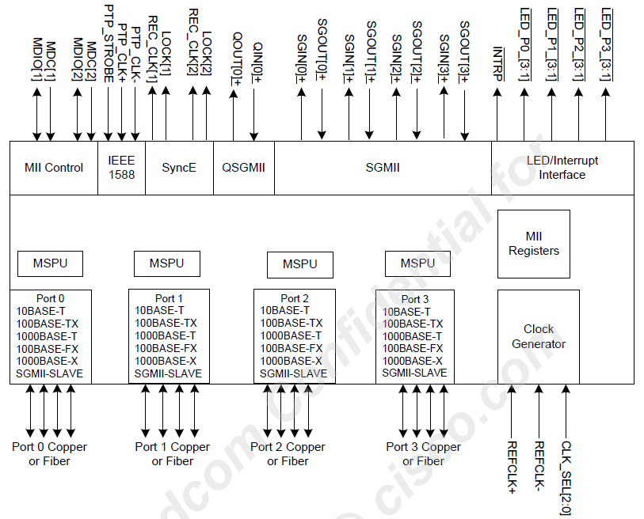
Figure 8. BCM54194 Quad 1G PHY block diagram – from datasheet

As shown in Figure 3, the SFP’s sideband and I2C interfaces will be controlled by the BCM57412 MAC and not the BCM54194 PHY. One of the two recovered line side clocks will be routed to the SyncE PLL and internal selection of the line side clock is required to be configured – see section 3.9.1.

Dual 10G PHY BCM82757
BCM82757 is a dual 10G PHY used for SFP/SFP+ on Fugazi. It is mainly used for MacSec support and Cisco Cleartag, but also provides LRM SFP+ support. The main features applicable to Fugazi are

- Dual ports, 10GbE XFI-to-SFI PHY
- Support SFP+ SR, LR, CR, and LRM optical interface
- Support for SyncE recovered clocks
- Supports 1000BASE-X for 1GbE operation
- Support for advanced SFP+ diagnostics, e.g. eye-mapping, SNR and BER
- Support for 256 bits MACSEC
- Supports Cisco Cleartag 3.4
- 1.0V core voltage and 1.2V/2.5V/3.3V I/O voltage
- 156.25MHz differential clock input

Figure 9 shows a simple block diagram of the BCM82757.

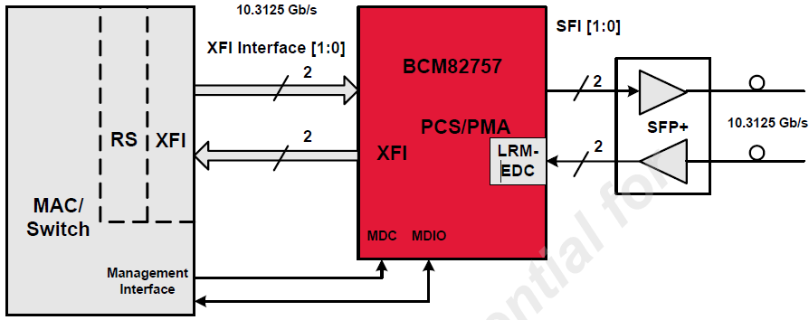
Figure 9. BCM82757 Dual 10G PHY block diagram – from datasheet

As shown in Figure 3, the SFP’s sideband and I2C interfaces will be controlled by the BCM57412 MAC and not the BCM82757 PHY. The two recovered line side clocks will be routed to the SyncE PLL – see section 3.9.1.

1G and 10G PHY SMI Address Map
The SMI (MDIO/MDC) bus is used by the BCM57412 10G MAC as control interface to the PHYs. Some SMI addresses are required by the host software to be unique and the addresses highlighted in Figure 10 and Figure 11 is planned for software use. The strapping for each PHY is done in hardware.

Figure 10. SMI addresses for 1G Quad PHYs

Figure 11. SMI addresses for 10G Dual PHYs

SFP/SFP+ Interface
Each SFP port will support a number of different SFP modules as listed in the PRD. The SFP pin-out is show in Table 12.

Table 12. SFP/SFP+ pin-out
Bottom of SFP module |  | Top of SFP module
Pin | Description | Pin | Description
1 | VeeT | 11 | VeeR
2 | TxFault | 12 | RD-
3 | TxDisable | 13 | RD+
4 | MOD-DEF(2) | 14 | VeeR
5 | MOD-DEF(1) | 15 | VccR
6 | MOD-DEF(0) | 16 | VccT
7 | RateSelect | 17 | VeeT
8 | LOS | 18 | TD+
9 | VeeR | 19 | TD-
10 | VeeR | 20 | VeeT

The SFP uses LVPECL signaling for data transmission and low speed TTL signals for status and control signals. For the LVPECL serial interface, 100Ω differential signaling (each signal’s impedance is 50Ω) is used. The low speed control interface provides transmitter control, transmitter monitoring and module identification. MOD-DEF0 is grounded on the SFP and used for insertion/removal detection. MOD-DEF[2:1] are used as SDA and SCL respectively and gives access to the ID PROM on the SFP where module information is stored.

The SFP requires 3.3V supply on the Vcc,x pins and pins Vee,x shall be connected to ground. OIR is provided in the form of a 1.1A nominal rated PTC that trips at around 2.2A.

TxFault is an output from the SFP indicating an error condition in the laser, TxDisable is an input to the SFP signaling to the module to disable the transceiver, and LOS is an output from the SFP indicating loss of signal in the receiver. These three control/status signals along with MOD-DEF[2:0] will be accessible from the FPGA.

I2C
The I2C busses for Fugazi is shown in Figure 12. More details for FPGA access are provided in Curie 1RU FPGA Hardware Functional Specification, EDCS-15093645 .

Figure 12. Fugazi I2C Busses

Clocks

SyncE
Synchronous network clocks are created by the 8A35004 SETS device. The IDT8A35004 received clock inputs from the 1G/10G PHYs and will output clocks to both 1G/10G PHYs and through a clock buffer to the 10G MACs. I high level clock tree for IDT8A35004 is shown in Figure 13. Detailed clock specifications are shown in Table 13 and Table 14.

Figure 13. Fugazi SyncE Clock Tree

Table 13. IDT8A35004 input clock Specifications.
Input | Source Device | Frequency | Type
CLK0 p | BCM54194 Quad 1G PHY0 “REC_CLK1” | 25MHz | CMOS
CLK0 n | BCM54194 Quad 1G PHY1 “REC_CLK1” | 25MHz | CMOS
CLK1 p | BCM54194 Quad 1G PHY2 “REC_CLK1” | 25MHz | CMOS
CLK1 n | BCM54194 Quad 1G PHY3 “REC_CLK1” | 25MHz | CMOS
CLK2 p | unused
CLK2 n | unused
CLK3 p/n | BCM82757 DUAL 10G PHY 4 “CLK_RCVCLK0” | 156.25MHz | CML, AC-coupled, 50Ω internal
CLK4 p/n | BCM82757 DUAL 10G PHY 4 “CLK_RCVCLK1” | 156.25MHz | CML, AC-coupled, 50Ω internal
CLK5 p/n | BCM82757 DUAL 10G PHY 5 “CLK_RCVCLK0” | 156.25MHz | CML, AC-coupled, 50Ω internal
CLK6 p/n | BCM82757 DUAL 10G PHY 5 “CLK_RCVCLK1” | 156.25MHz | CML, AC-coupled, 50Ω internal

Table 14. IDT8A35004 output clock Specifications.
Output | Destination Device | PLL | Frequency | Type
Q0_P/N | Unused (Clock buffer for BCM57412 core clock, but not installed) | DPLL0 | 50MHz | LVPECL
Q1_P | FPGA | DPLL0 | 25MHz | CMOS
Q1_N | Unused | DPLL0 | 25MHz | CMOS
Q2_P/N | BCM54194 Quad 1G PHY0 “REF_CLK+/-” | DPLL1 | 125MHz | LVPECL, AC-coupled
Q3_P/N | BCM54194 Quad 1G PHY1 “REF_CLK+/-” | DPLL1 | 125MHz | LVPECL, AC-coupled
Q4_P/N | BCM82757 DUAL 10G PHY 4 “REFCKP/N” | DPLL2 | 156.25MHz | 1V_{PP}, AC-coupled
Q5_P/N | BCM82757 DUAL 10G PHY 5 “REFCKP/N” | DPLL2 | 156.25MHz | 1V_{PP}, AC-coupled
Q6_P/N | BCM54194 Quad 1G PHY2 “REF_CLK+/-” | DPLL3 | 125MHz | LVPECL, AC-coupled
Q7_P/N | BCM54194 Quad 1G PHY3 “REF_CLK+/-” | DPLL3 | 125MHz | LVPECL, AC-coupled

Miscellaneous clocks
Table 15 lists clocks and crystals not previously defined above.

Table 15. Miscellaneous Clocks for Fugazi
Source | Speed | Target Device | Input Clock | Interface
Intel Broadwell | 24MHz | Intel Skylake-D | CLK_24M0_PMSYNC | 1.05V Single Ended
Intel Broadwell | 24MHz | Mictor Header | CLK_24M0_LPC_DBG | 3.3V CMOS
Intel Broadwell | 24MHz | FPGA | CLK_24M0_LPC_FPGA | 3.3V CMOS
XTAL | 25 MHz | Intel Skylake-D | XTAL_IN/OUT | XTAL
OSC | 25MHz | FPGA | CLK25P0M | 3.3V CMOS
XTAL | 24 MHz | USB2642 | XTAL1/2 | XTAL
XTAL | 32.7680 KHz | Intel Skylake-D | RTCX1/X2 | XTAL

IO FPGA
Fugazi has an IO FPGA similar to existing ISR4K platforms. For details please refer to Curie 1RU FPGA Hardware Functional Specification, EDCS-15093645 .

LED Daughter Card
Fugazi will have a daughter card with status LEDs and backlit logo LEDs. The LED DC is reused from the Curie program. See the FPLED_Board_Spec, EDCS-15985755.

For details on the LED behavior, please see section 5.1.

Trust 2.0
To support Trust Tech 2.0 the previous ACT2 chip will not be adequate. For initial bringup and backup, ACT2 will still be present on the HW, but it is planned to be depopulated in production.

To achieve Trust 2.0, Curie will rely on the implementation using “Aikido” as shown in Error! Reference source not found.. Aikido is an FPGA implementation using M2S005TS. Note that the Aikido chip has the ability to reset the CP CPU autonomously of the FPGA.

Figure 14. Trust 2.0 implementation using Aikido.

For early prototypes (revision 1 and 2), Aikido was implementated by interfacing to Kingfisher in the FPGA as shown in Figure 15. The change is transparent to software, but the FPGA and Aikido firmware images are different between the two implementations.

Figure 15. Trust 2.0 implementation using Aikido – proto type only.

Fan tray connector
Fugazi platforms will use 4 individual 38mm fans. The fan connector pin-out is similar to Sword and Dagger and is shown in Table 16.

Table 16. Fugazi Fan Connector Pinout
Pin Number | Description
1 | GND
2 | 12V
3 | TACH (input to host)
4 | PWM (output from host)

The fans are planned to have Cisco Smartfan technology for identification purposes. Please see the Cisco Smart Fan Specification, EDCS-11544582.

Current Measurement
There are a number of current sensors in the system. Figure 16 shows the sensors. The power supplies have built in sensors. The motherboard has 3 sensor locations; two for main power into the motherboard and one for power to the fans.

Figure 16. Fugazi 1RU System Current Sensors

The current sensors on the motherboard uses sense resistors and an amplifier to generate an analog voltage which is then sampled by the power sequencer. The sense resistor needs to be designed for the appropriate power requirements and the amplifier and ADC requirements. The amplifier used is a TI INA180, Cisco part number 15-107025-01, with 50 times amplification.

Table 17 and Table 18 show the design summary for the sensors on the motherboard.

Table 17. Fugazi Motherboard Input Current Sensing

Table 18. Fugazi Fan Current Sensing

JTAG Chain
The JTAG chain is shown at a high level in Figure 17 for Fugazi. The JTAG chain supports:

- Normal manufacturing boundary scan
- Secure JTAG
- Access to the FPGA for programming and debugging using an Altera USB byte blaster
- Access to the Aikido FPGA for programming and debugging.
- Access to the Skylake-D CPU using an XDP header

Figure 17. Fugazi JTAG Chain

Power
The Fugazi voltage rails and power up sequencing is described in the Fugazi Power Budget, EDCS-18301088.

Voltage Margin
Only 3.3V can be margined. The margining is done through the I2C bus to the device; the NIOS ENV MCU control the TPS53659.

M.2 Expansion Flash
Fugazi will support an M.2 slot for mixed use of PCIe based NVME modules and a newly defined eMMC USB card. The M.2 expansion card can be removed externally

Figure 18 shows a block diagram of the connections.

Figure 18. M.2 NVME/SATA/USB Block Diagram

The M.2 NVME slot has connects to the CPU with 2 lanes PCIe gen3. The planned supported parts for the NVME is shown in Table 19.

Table 19. Supported M.2 NVME Modules
Size | CPN | Description | Vendor MPN¹⁾
600GB | 16-101462-01 | IC-FEPROM-M,SSD,PCIe,1000GB,3.3V,M.2,0 to 55 C,DWPD<1,SRGBU only | SSDPELKX010T801
1) Please use Agile for latest MPNs and qualified parts

A new USB based module that can support lower densities and be removed by the user will also be supported. The USB module will be USB2.0 based and is expected to be 32GB maximum initially. The USB module will use the controller (USB2642) and eMMC modules that are also used on the Curie 1RU motherboard for bootflash.

To determine the type of card that is installed, the sideband signals (existing or new) in Table 20 provided:

Table 20. M.2 Expansion Slot Pin to Module Description.
M2_PRESENT_L  (pin 75 - NEW) | USB_PRESENT_L  (pin 28 – NEW) | PEDET  (pin 69) | Module
1 | X | X | Module not present
0 | 1 | 0 | M.2 SATA
0 | 1 | 1 | M.2 NVME
0 | 0 | 0 | M.2 USB
0 | 0 | 1 | M.2 with EEPROM for type

Software Considerations
This section describes requirements that is place on software by the hardware.

Memory Maps
For details on the FPGA register definition, please refer to reference [1].

Programming Requirements / Suggestions

BIOS
BIOS needs to ensure the following at a minimum:
- SPI clock speed must be set to 20MHz when reading the BIOS content.
- Fast read must be disabled when reading the BIOS content
- Dual read from SPI is enabled
- SPI devices in that must appear in the VSCC table:
  - Macronix MX25L25635FMI-10G: 0xC22019 VSCC: 0x20452045
  - Micron MT25QL256ABA8ESF-0SIT: 0x20BA19 VSCC: 0x20052005
- Ensure that PCIe bifurcation is set as per Table 5.
- Enable clock outputs as per Table 6
- Disable ASPM for PCH PCIe downstream devices
- May need to add routing rules for PCH PCIe INT/PIRQx.
- FPGA memory space is reserved at FED40000-FED4FFFF (TPM memory space)
- Enable SMLink0 read of CPU temperature
- Enable SMLink1 read of PCH temperature

BIOS upgrade and PROM selection is similar to existing ISR4K products. Please see [1] for details.

BCM57412
BCM57412 requires an external NVRAM component to store various device firmware and configuration options. NVRAM is managed by the Hardware Resource Manager (HWRM) firmware executing in the embedded processor.
- The SPI interface initially read the NVRAM’s Manufacturing and Device ID at 18.75 MHz frequency. The normal operating of SCLK frequency is 37.5 MHz.
- The NVRAM must be programmed with boot code and contain a valid set of default configuration (can be got from software kit) to ensure the chip be enumerated correctly in an OS environment.

BCM82752/BCM82757
Based on compliance mask testing, the following changes are required changes from the default values:
- Write to register 0x4800D0A5 (TX_CTRL_5) = 0x2000. (Bit 14=1: enables pre path)
- Write to register 0x4800D110 (TX_FIR Control1 Register) = 0x00E0. (bit 9:5=0111: TX FIR post override value)
- Write to register 0x4800D111 (TX FIR Control2 Register) = 0x8028. (bit 15 = txfir_override_en)

FPGA Programming Requirements
For details on the FPGA register definition, please refer to reference [1].

Other Software Considerations

Cookie EPROM
The system cookie information is documented in 61-104107-XX for the Fugazi Motherboard.

User Interface Considerations/ User Experience

LEDs
LEDs and LED usage is listed in Table 21.

Table 21. Fugazi LEDs.
LED | Color | Description
LOGO | Blue | Cisco Logo LED  Off: The system is powered off  Blue: The system is powered on
PSU | Green/  Amber | Power Supply Status  Off: The system is powered off  Yellow: A Power Supply in the system is not functioning correctly  Green: All installed PSUs are operating correctly
STATUS | Green/  Amber/  Red | System Status  Red: The system is booting  Blinking Red: The system has failed a hardware integrity error  Yellow: Rommon has completed booting and system at Rommon prompt or booting platform software.  Green: Normal System Operation
MINOR ALARM | Amber | Minor Alarm  Off: No Minor Alarm  Amber: Minor Alarm Asserted
MAJOR ALARM | Red | Major Alarm  Off: No Major Alarm  Red: Major Alarm Asserted
CRITICAL ALARM | Red | Critical Alarm  Off: No Critical Alarm  Red: Critical Alarm Asserted  Note that this LED is on at power on and turns off when IOS has booted.
LINK | Green | RJ-45 Management Ethernet Link LED  Off: No link  Green: Ethernet cable present and link established with other side
SPEED | Green | RJ-45 Management Ethernet Speed LED  Off: No Link  Blinking Green: blink frequency indicates port speed:  1 blink – 10Mbps link speed  2 blinks – 100Mbps link speed  3 blinks – 1000Mbps link speed
USB CON | Green | USB Console Active  Green indicates that the active console port is USB. When this is “On” the SER CON LED will be “Off”.
SER CON | Green | Serial Console Active  Green indicates that the active console port is RJ-45. When this is “On” the USB CON LED will be “Off”.
SFP | Green/  Yellow | SFP port 0/1 Link LED  Off: Not present or not configured  Yellow: Loss of Signal  Green: Link established

Power Supply Requirements

Power Budget
The detailed power budget can be found in the Fugazi Power Budget, EDCS-18301088.

Power Budget Summary
Table 22 shows a derived high level power budget for Fugaz. The total power of a fully loaded system comes out to around 230W. A 450W PSU will be used for Fugazi as the basic PSU. It is expected that the MB and all modules will not run at maximum power draw.

Table 22. Curie Radium High Level Power Budget
Platform | Qty | Power | Total Power
Fan | 4 | 10W | 40W
SFP | 8 | 1W | 8W
SFP+ | 4 | 1.5W | 6W
M.2 SSD | 1 | 6.5W | 6.5W
USB-A | 1 | 4.5W | 4.5W
USB-C | 1 | 7.5W | 7.5W
Motherboard | 1 | 157 W | 157W
Total |  |  | 229.5W

Main Power Supplies
Fugazi will use the same power supply form factor as was used on Nightster/Juno. Please refer to section 11.3 for detailed information.

Mechanical Description
TBD

Signal Integrity Considerations

Impedance Control
The below impedance control requirements apply to Fugazi Motherboard:

- Single ended trace width for external (Top/Bottom) layers = 5.5 mils. Target characteristic impedance = 55 ohms +/- 10% for single ended trace in all external layers
- Single ended trace width for external (Top/Bottom) layers = 6.5 mils. Target characteristic impedance = 50 ohms +/- 10% for single ended trace in all external layers
- Single ended trace width for internal layers = 4 mils. Target characteristic impedance = 55 ohms +/- 10% for single ended trace in all internal layers
- Single ended trace width for internal layers = 5.1 mils. Target characteristic impedance = 50ohms +/- 10% for single ended trace in all internal layers
- Differential trace width = 4.5mils and spacing = 5 mils (pitch = 9.5 mils) for external (Top/Bottom) layers. Target characteristic impedance = 100 ohms +/- 10% for differential trace in all external layers
- Differential trace width = 4.5mils and spacing = 7.5 mils (pitch = 12 mils) for internal layers. Target characteristic impedance = 100 ohms +/- 10% for differential trace in all internal layers
- Differential trace width = 7.0 mils and spacing = 6 mils (pitch = 13 mils) for external (Top/Bottom) layers. Target characteristic impedance = 85 ohms +/- 10% for differential trace in all external layers
- Differential trace width = 5.5 mils and spacing = 7.5 mils (pitch = 13 mils) for internal layers. Target characteristic impedance = 85 ohms +/- 10% for differential trace in all internal layers
- Differential trace width = 6.0 mils and spacing = 5 mils (pitch = 11 mils) for external (Top/Bottom) layers. Target characteristic impedance = 90 ohms +/- 10% for differential trace in all external layers
- Differential trace width = 4.7 mils and spacing = 5.3 mils (pitch = 10 mils) for internal layers. Target characteristic impedance = 90 ohms +/- 10% for differential trace in all internal layers
- Single ended trace width in the package BGA field is 3.5 mils with target impedance = 60 ohm +/- 10% in all internal layers.
- Single ended trace width for external (Top/Bottom) layers = 10 mils. Target characteristic impedance = 40 ohms +/- 10% for single ended trace in all external layers
- Single ended trace width for internal layers = 7.125 mils. Target characteristic impedance = 40 ohms +/- 10% for single ended trace in all internal layers
- Differential trace width = 8.1 mils and spacing = 4.9 mils (pitch = 13 mils) for external (Top/Bottom) layers. Target characteristic impedance = 80 ohms +/- 10% for differential trace in all external layers
- Differential trace width = 6.5 mils and spacing = 6.5 mils (pitch = 13 mils) for internal layers. Target characteristic impedance = 80 ohms +/- 10% for differential trace in all internal layers

Signal Crosstalk
Table 23 shows the signal crosstalk requirements for the Fugazi platforms.

Table 23. Signal Crosstalk Requirements
Type | Signal Speed | Minimum Crosstalk | Maximum Crosstalk
Wide bus (DDR4) | 2400 MHz | 20mV | 40mV
Serdes | 10G | 10mV | 20mV
Serdes | 8G | 15mV | 25mV
Serdes | 5G | 15mV | 30mV
Serdes | 2.5G | 20mV | 40mV
Clock | <500Mhz | 30mV | 50mV

PCB Routing Requirements
Routing requirements are specified in the schematic addprop files.

PCB Stackup
Target PCB stack-up are shown in Figure 19.

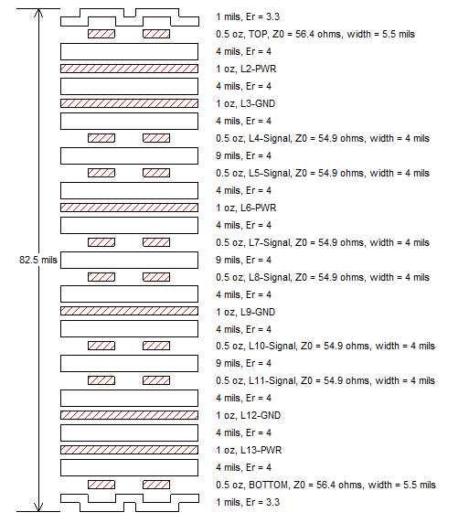
Figure 19. Fugazi Motherboard 14-layer Stackup

Simulation Results
Signal Integrity simulation results can be found here:
\\rtp5-netapp-ns\local\si-space10\projects\ISR\Fugazi

Testing Considerations
The system will support the following margining for Environmental Development Validation Testing:
- Voltage high and low margining for 3.3V

Testability Considerations
Specify any required diagnostic capabilities and special testbed requirements. Reference any requirements that are untestable or difficult to test, with a description of how this risk factor is being mitigated, e.g., a schedule and responsibility for making all requirements testable.
<<ISO requirement>>
<Body>

Manufacturing Considerations

System, Board Part Numbers
Fugazi consists of the motherboard board and the LED daughtercard. Cisco Part Numbers are shown in Table 24. Note that the LED DC CPNs are shared with the Green Day and Ramones programs. For more information on the LED daughter card please see section 3.11.

Table 24. System Part Numbers.
Field | Fugazi | LED DC
TAN
Elmech
73- | 73-19748-xx | 73-101941-xx
28- | 28-14318-xx
60- | 60-103505-xx
61- | 61-104107-xx
92- | 92-103563-xx
PID | C8500L-8S4X | N/A
CID | 0x10E0 | N/A

Programmable Part Numbers

Table 25. Fugazi Programmable Part Numbers.
RefDes | Raw CPN | 17- CPN | MPN | Description | Programming | Source Location
U2_PSQ | 15-104664 | 17-15616 | CYSHM35925I-M068LTI | Power Sequencer | Pre-Programmed | SVN: mcu
U1_0V9C | 15-105513 | 17-15617 | TPS53622A | DC/DC | Pre-Programmed | SVN: power_ti
U1_1V2C | 15-105513 | 17-15618 | TPS53622A | DC/DC | Pre-Programmed | SVN: power_ti
U1_1V0C | 15-105513 | 17-15619 | TPS53622A | DC/DC | Pre-Programmed | SVN: power_ti
U1_1V8C | 15-105255 | 17-15620 | TPS53659 | DC/DC | Pre-Programmed | SVN: power_ti
U1_3V3 | 15-105255 | 17-15622 | TPS53659 | DC/DC | Pre-Programmed | SVN: power_ti
U6_IO | 16-4167 | 17-15388  (17-15650) | N25Q064 | FPGA | Pre-Programmed | SVN: fpga
U2_AK | 16-4221 | 17- 15651 | N25Q128 | Aikido, EEPROM | Pre-Programmed | SVN:
U1_AK | 16-100726 | 17-15500 | M2S005S | Aikido, FPGA | Pre-Programmed | SVN:
U1_UCN | 15-11263 | 17-8994 | CY7C64215 | USB Console | Pre-Programmed | (leveraged)
U8B_CSPI  U7B_CSPI | 16-100597 | 17-15623 | MT25QL256 | Rommon | Pre-Programmed | (From SW team.)
U3_EMMC | 16-3366 |  | AT25DF041 | eMMC Controller | Diagnostics | (leveraged)
U2_TG0/  U2_TG1/  U2_TG2/  U2_TG3 | 16-4167-04 | 17-15877 | MX25L64 | 10G MAC | Preprogram | SVN:
U2_TG4/  U2_TG5 | 16-4167-04 | 17-15878 | MX25L64 | 10G MAC | Preprogram | SVN:
U2_NK | 16-3541 | 17-15621 | ATC24M01 | SyncE | Preprogram | SVN:
n/a | n/a |  | n/a | NIOS | Packaged in FPGA | SVN

Power Supply Part Numbers

Table 26. Fugazi Power Supply Part Numbers.
 | 450W PSU AC | 450W DC | 450W HVDC
341 | 341-101130-01 | 341-101131-01 | 341-101156-01
61-
95- | 95-113186-01 | 95-113187-01 | 95-113368-01
PID | PWR-CH1-400WAC | PWR-CH1-400WDC | PWR-CC1-400WHV
CID | 0x10F0 | 0x10F1 | 0x01F9

Estimated Costs
Cost data is owned by Manufacturing

Requirements Traceability Considerations

<<TL 9000: ADDITIONAL REQUIREMENT FOR TL 9000 COMPLIANCE>>
Requirements traceability is required for TL 9000 registration. Traceability may be performed manually, or with assistance of automated software tools.

If the requirements in the SFS are not of sufficient detail to support traceability to test cases, you may need to trace the product requirements to the more detailed functional requirements specified in this HW functional specification. In this situation, provide unique identifiers for all functional requirements and trace product requirements to functional requirements consistent with your organization’s strategy for requirements traceability. If the project has a separate traceability matrix provide a link to that document.

Refer to the Common Requirements Traceability Handbook EDCS-400506 for a thorough description of traceability and some examples of a manual implementation.

References

Cisco Documents
- Fugazi System Functional Specification, EDCS-15396836.
- Fugazi Power Budget, EDCS-18301088
- Curie 1RU FPGA Hardware Functional Specification, EDCS-15093645
- Utah, Sword, Dagger Hardware Functional Specification: EDCS-1202397
- FPLED_Board_Spec, EDCS-15985755
- Fugazi_mother_board_Design_Review_Checklist, EDCS-18342138
- Cisco_Fugazi_Executive_Summary_Action_Tracker_R0629-477.SM01_v2.0, EDCS-15974828 (Schematic modeling results from rev1)
- CHG Hardware Development Process, EDCS-1511434
- Cisco Derating Guidelines, EDCS-517316

Vendor Documents

Standards

Safety Standards
For details on the Safety test plan and standards, please refer to XXX

EMC Standards

Table 27. Fugazi required EMC Standards.
Category | Standard/Specification | Level/Class | Notes
EMC (Emissions) | FCC 47CFR15  AS/NZS CISPR 22  CISPR 22  EN55032  ICES-003  VCCI  KN 32  CNS-13438 | Class A | 6dB margin
EN61000-3-2 Power Line Harmonics ^{(EMI-1)}
EN61000-3-3 Voltage Changes, Fluctuations, and Flicker ^{(EMI-1)}
EN61000-3-11 Voltage Fluctuations and Flicker ^{(EMI-2)}
EN61000-3-12 Power Line Harmonics ^{(EMI-3)}
EMC (Immunity) | IEC/EN61000-4-2 Electrostatic Discharge Immunity | 8kV contact, 15kV air | Criteria A ^{(EMC-1)}
 | IEC/EN61000-4-3 Radiated Immunity | 10V/m | Criteria A
 | IEC/EN61000-4-4 EFT-B Immunity (AC Power Leads) | 2kV | Criteria B
 |  | 1kV | Criteria A
 | IEC/EN61000-4-4 EFT-B Immunity (DC Power Leads) | 2kV | Criteria B
 |  | 1kV | Criteria A
 | IEC/EN61000-4-4 EFT-B Immunity (Signal Leads) | 1kV (indoor) | Criteria B
 |  | 0.5kV (Indoor) | Criteria A
 | IEC/EN61000-4-5 Surge AC Port | 4kV L-GND, 2kV L-L | Criteria B
 | IEC/EN61000-4-5 Surge DC Port | 1kV L-GND, 1kV L-L | Criteria B
 | IEC/EN61000-4-5 Surge Signal Port | 1kV L-GND | Criteria B
 | IEC/EN61000-4-6 Immunity to Conducted Disturbances | 10Vrms | Criteria A
 | IEC/EN61000-4-8 Power Frequency Magnetic Field Immunity | 30A/m | Criteria A
 | IEC/EN61000-4-11 Voltage Dips, Short Interruptions, and Voltage Variations | Various ^{(EMC-2)} | Various ^{(EMC-2)}
 | KN 35 ^{(EMI-2)}
EMC (ETSI/EN) | EN 300 386 Telecommunications Network Equipment (EMC) ^{(EMC-3)}  EN55022 Information Technology Equipment (Emissions)  EN55024/CISPR 24 Information Technology Equipment (Immunity)  EN50082-1/EN61000-6-1 Generic Immunity Standard ^{(EMC-4)} | OTC  Class A

^{EMI-1} Applicable to LV AC equipment with rated input current up to and including 16 A per phase.
^{EMI-2} Applicable to equipment with rated input current <= 75A and subject to conditional connection
^{EMI-3} Applicable to equipment with rated input current > 16A and <= 75A per phase.

^{EMC-1} Criteria A is required. In the EMC formal report, formal ESD testing to Criteria B is permitted. Verification to Criteria A shall be performed during de-risk or formal start.
^{EMC-2} Requirements for Voltage DIPs and Short Interruptions as specified in EN55024, CISPR 24, EN300386, and EN61000-6-1.
^{EMC-3} Location other than Telecommunications center (OTC).
^{EMC-4} Generic Immunity for residential, commercial, and light industrial environments.

Glossary
TBD

Attachments

Review Action Items

Review Notes
Table 28. Review Action.
Item | Description | Resolution

End of Document

